**Maths Practice : Maths Mind Trainer**

App is developed for improve user maths calculation ability by just playing this game.

As you know that we will try to add most of feature on app that is required on android game. like Leaderboard, Achievement, Save score on Cloud, AdMob integration and All PSD provide for change screen.

But to change we need to follow some step to change.

**Table of Contents**

1. AdMob Change
2. Facebook Change
3. Google Play Game Service
4. For cloud storage please follow this step
5. Import project on Eclipse and basic change

**A) AdMob Change:**

    1. Right now admob integration you have to just change yon ad-unit id replace your id.  
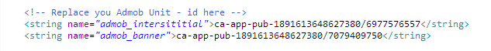

    2. This parameter is set true if you are testing app set false when you publish app on google play.

D:\Mobile Application\App Sell\idea\Maths Practice\Product Source Code\Document\assets\images\admob.png

**B) Facebook Change:**

    Create App on Facebook and change Facebook app id here.  
D:\Mobile Application\App Sell\idea\Maths Practice\Product Source Code\Document\assets\images\facebook.png  
This link will helpful but you have to just follow step 5 for create Facebook id.  
<https://developers.facebook.com/docs/android/getting-started/>

**C) Google Play Game Service:**

         This is best feature on this app please do this step carefully also please understand what is game service, leaderboad, achievement etc..

* **1.Getting start with Google Game Service**
* **2.Setting Game service on Android Eclipse**
* **3.Create Achievement on Developed Console -> Game Services**
* **4.Create Leaderboard on Developed Console -> Game Services**
* **5.Link Game Service to android app on Developed Console -> Game Services. Create two one for test and one for live.**
* **6.Get All Source code and copy into id.xml from Developed Console -> Game Services**
* **7.Add Test user id on game services Developed Console -> Game Services**

        Please read carefully about getting start with Game service and Setup Game service on Android app.

**1. Getting start with Google Game Service:**

<https://developers.google.com/games/services/android/quickstart>

**2. Setting Game service on Android Eclipse**

<https://developers.google.com/games/services/android/quickstart#step_2_set_up_the_game_in_the_dev_console>

**3. Create Achievement on Developed Console -> Game Services:**

Before you do next step please create Game service on Google Play Developer console and add Achievement and Leaderboard on Developer console.

        Achievement Look like this:

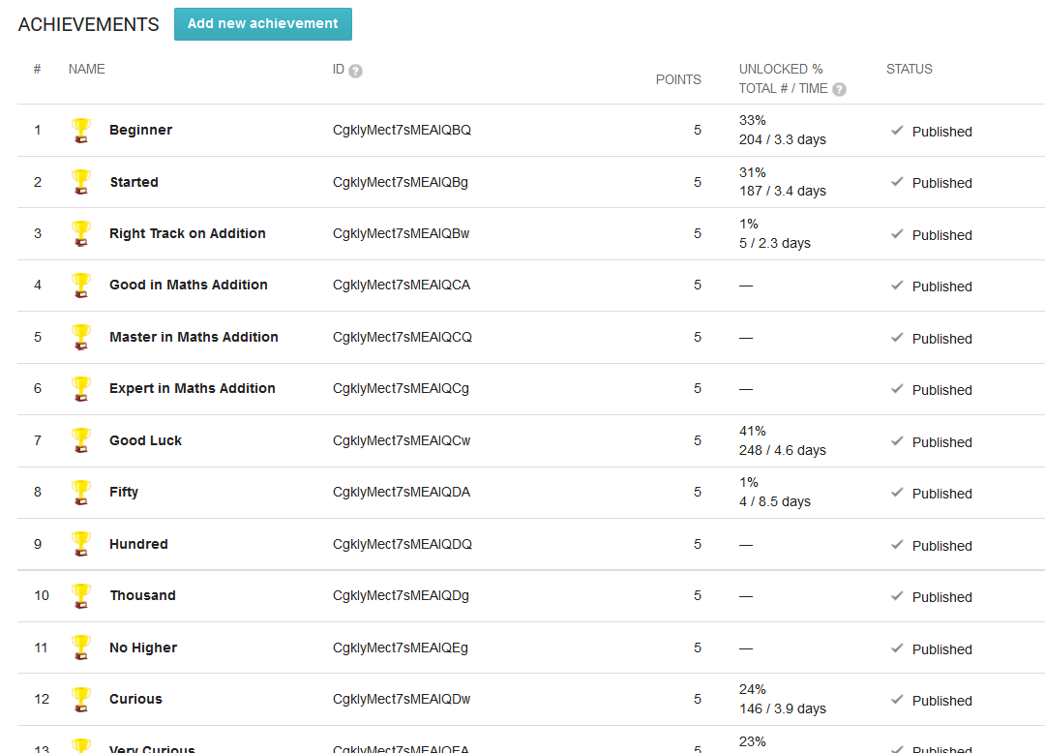

**4. Create Leaderboard on Developed Console -> Game Services**

And Leaderboard Look like this.

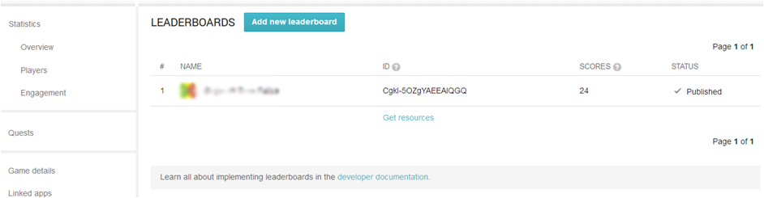

**5. Link Game Service to android app on Developed Console -> Game Services. Create two one for test and one for live.**

Now link you app to this game service.

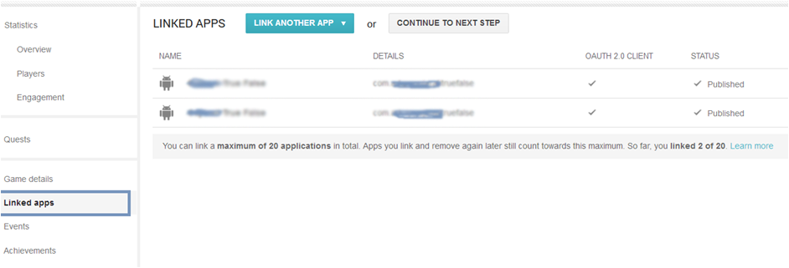

**6. Get All Source code and copy into id.xml from Developed Console -> Game Services**

Also copy Get Resource as following:

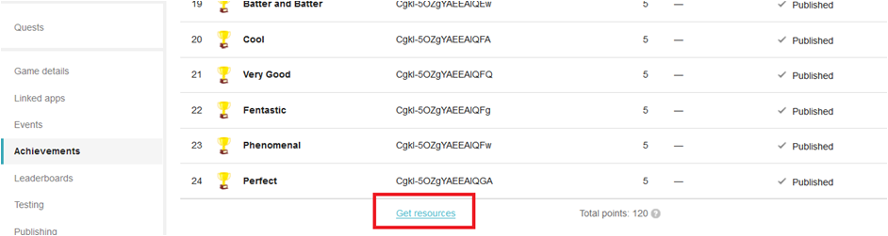

on Click "Get Resource" it will look like below:

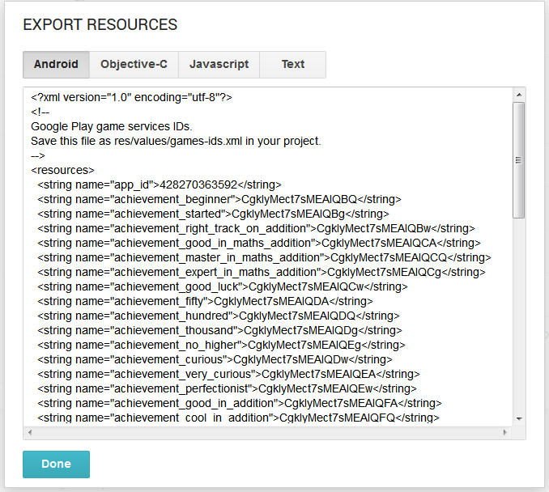

copy this xml code and replace it on ids.xml file and save it.

**7. Add Test user id on game services Developed Console -> Game Services**

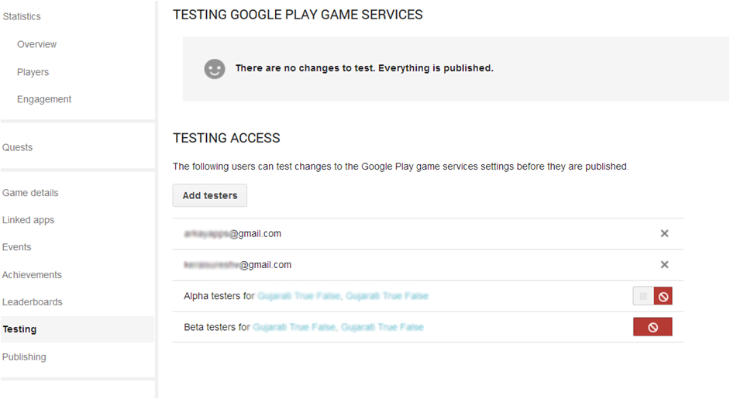

**D) For cloud storage please follow this step**

1. On Google Play developed Console-> Game service-> Select Game-> Game Detail-> you can see there "API Console project" click link below with project name.

2. It will be something like this : This game is linked to the API console project called **'App Name'**

3. It will redirect to <https://console.developers.google.com/>

4. Now click API & Auth->Apis

5. Now Turn ON app below service it's free..

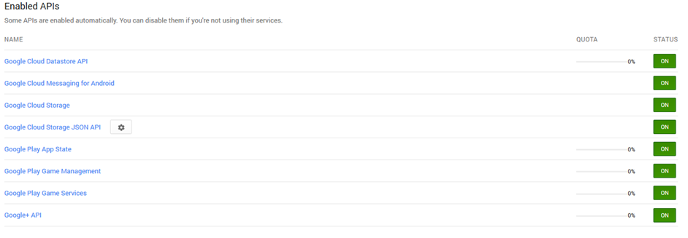

Now you almost work is done.

**E) Import project on Eclipse**

     Following video is help full to project setup. This app have not web side console so please not follow that step on this app.

**Cover Following Point:**

* How to Import Project with Game service and Base Game
* How to change Application name?
* How to change package name?
* How to change Admob id Change test mode to live mode?